Contoso Insurance Code Sample

Component List
This table lists all the Azure components used in the code sample and describes what they are used for.

Type | Name | Sub Components |  | Description
 |  | Type | Name
SQL server | contosoinsurance | SQL Database | MobileClaims | Mobile Claims Database the mobile application interacts with.
 |  | SQL Database | CRMClaims | CRM Claims Database everything but the mobile app interacts with.
Storage account | contosoinsurancestorage | Blobs | other-party-plate-images | Container to store other party license plate images
 |  |  | other-party-card-images | Container to store other party insurance card images
 |  |  | other-party-license-images | Container to store other part driver’s license images
 |  |  | vehicle-images | Container to store the customer’s vehicle images
 |  |  | claim-images | Container to store claim images
 |  | Queues | mobile-claims | MobileClaim Queue
 |  |  | new-claims | NewClaimForApproval Queue
App Service | contosoinsurance | Web App |  | MVC 5 App used for Claims Adjusters
 | contosoinsurance-api | Web API | SubmitClaimForProcessing | Custom API for the mobile App:  Writes to DB, when write is done, then writes to MobileClaim Queue.
 |  | Web API |  | TableControllers for the Mobile App
Function App | contosoinsurance-function | Function | HandleMobileClaim | Triggers on mobile-claims queue and writes to CRM Claims SQL database and new-claims queue, removes item from mobile-claims queue. Returns current claim and other party from CRM Claims SQL database. Calls OCR to process license plate, driver’s license, and insurance card other party images. Updates the current claim and other party in CRM Claims SQL database with the data returned from the OCR process.
 |  |  | HandleNewClaim | Triggers on new-claims queue and invokes Logic App, removes items from new-claims queue.
 |  |  | HandleManualClaim | Invoked by the ContosoClaimManualApprover Logic app to update the CRM Claims SQL database.
 |  |  | AutoApproveClaim | Invoked by the HandleNewClaim Azure Function. Queries the CRM Claims SQL database and looks to see if the current customer has submitted a claim before. If no previous claims are found for the current customer, then auto approves the claim. If previous claims are found for the current customer, then does not auto approve the claim.
 |  |  | Shared | Contains the common csx files.
 |  |  |  | When a claim is manually approved or rejected the CRM Claims Database is updated and an email and push notification is sent to the customer.
Logic App | ContosoInsuranceClaimAutoApprover |  |  | See the description for this Logic App below.
 | ContosoInsuranceClaimManualApprover |  |  | See the description for this Logic App below.
Application Insights | ContosoInsurance
Notification Hub | ContosoClaimApprovedNotification

 | Created |  | Not Created (Coming in Subsequent Phase)

Logic Apps
This section illustrates the Logic Apps used in the code sample.

ContosoInsuranceClaimAutoApprover
This logic app auto approves or rejects claims. See the Src\Contoso Insurance.vsdx Visio diagram to see where it fits into the entire process.
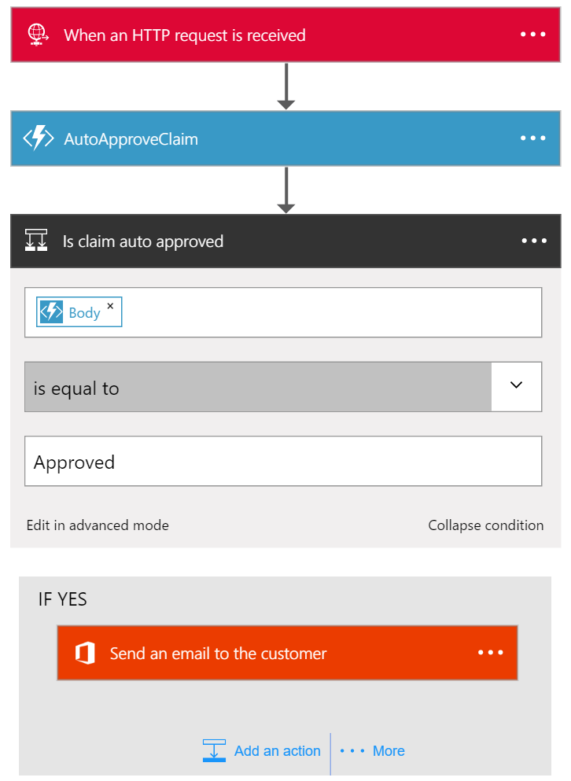

ContosoInsuranceClaimManualApprover
This logic app handles manually approved claims. See the Src\Contoso Insurance.vsdx Visio diagram to see where it fits into the entire process.
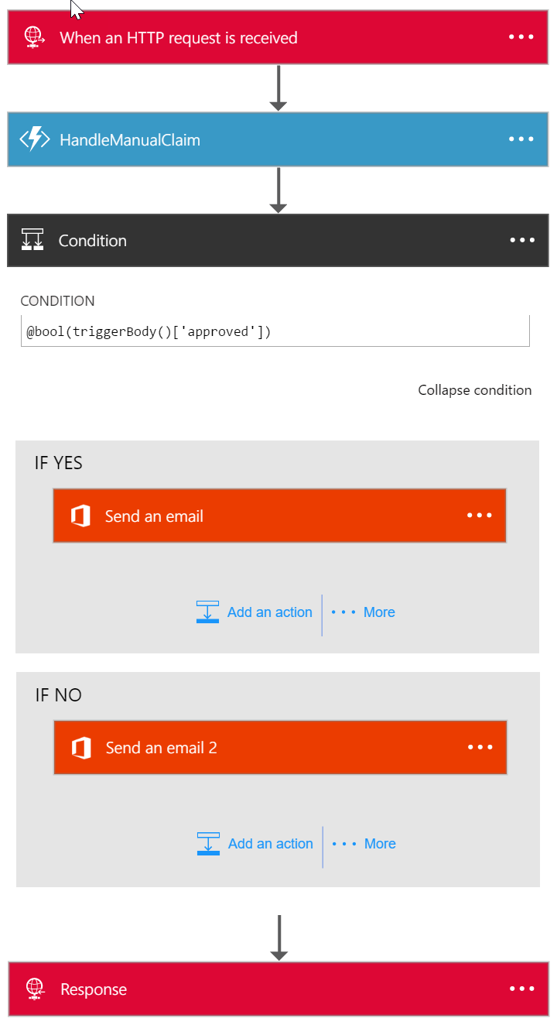

Mobile Claims Database
The mobile app interacts with the Mobile Claims database. These tables document the database schema and describe all of the columns.

Claims Table
Column | Type | Description
Id | nvarchar | Primary key for this table auto-generated by mobile app
Description | nvarchar | Description of incident entered in mobile app
DateTime | datetime | Date and time the incident occurred auto-generated by mobile app
Coordinates | geography | GPS coordinates where incident occurred auto-generated by mobile app based on current GPS location
Vehicle Id | int | The Id of the vehicle selected in mobile app
OtherPartyMobilePhone |  | The mobile phone number entered into the mobile app.

CustomerVehicles Table
Column | Type | Description
Id | nvarchar | Primary key for this table
UserId | nvarchar | Pre-populated from a SQL Script to seed the demo data
LicensePlate | nvarchar | Pre-populated from a SQL Script to seed the demo data
VIN | nvarchar | Pre-populated from a SQL Script to seed the demo data
Vehicle Id | int | Foreign key to Claims table

CRM Claims Database
Everything but the mobile app interacts with the CRM Claims database. These tables document the database schema and describe all of the columns.

Claims Table
Column | Type | Description
Id | int | Primary key for this table auto-generated by mobile app
Description | nvarchar | Description of incident entered in mobile app
DateTime | datetime | Date and time the incident occurred auto-generated by mobile app
Coordinates | geography | GPS coordinates where incident occurred auto-generated by mobile app based on current GPS location
Correlation Id | uniqueidentifier | Correlation Id auto-generated by mobile app
Status | int | Used to track status of the incident. Possible status values include: Submitted, Auto Approved, Auto Rejected, Manual Approved, Manual Rejected
CustomerId | int | Foreign key to Customer table
Type | nvarchar | Always set to the value Automobile for this phase of the demo
DueDate | date | Calculated – Use Date column above and add 1 week
DamageAssessment | int | Set by the web app. Choices include: Severe, Moderate, Minimal
Correlation Id | uniqueidentifier | Correlation Id auto-generated by mobile app
Vehicle Id | int | The Id of the vehicle selected in mobile app
OtherPartyId | int | Foreign key to OtherParties table

ClaimImages Table
Column | Type | Description
Id | int | Primary key for this table
ClaimId | nvarchar | Foreign key to Claim table
ImageUrl | nvarchar | URL to blob image in claim-images container

Customers Table
Column | Type | Description
Id | int | Primary key for this table
FirstName | nvarchar | Pre-populated from a SQL Script to seed the demo data
LastName | nvarchar | Pre-populated from a SQL Script to seed the demo data
Street | nvarchar | Pre-populated from a SQL Script to seed the demo data
City | nvarchar | Pre-populated from a SQL Script to seed the demo data
State | nvarchar | Pre-populated from a SQL Script to seed the demo data
Zip | nvarchar | Pre-populated from a SQL Script to seed the demo data
DOB | date | Pre-populated from a SQL Script to seed the demo data
Email | nvarchar | Pre-populated from a SQL Script to seed the demo data
PolicyStart | date | Pre-populated from a SQL Script to seed the demo data
PolicyEnd | date | Pre-populated from a SQL Script to seed the demo data
PolicyId | nvarchar | Pre-populated from a SQL Script to seed the demo data
DriversLicenseNumber | nvarchar | Pre-populated from a SQL Script to seed the demo data
MobilePhone | Nvarchar | Pre-populated from a SQL Script to seed the demo data

CustomerVehicles Table
Column | Type | Description
Id | nvarchar | Primary key for this table
CustomerId | int | Foreign key to Customer table
LicensePlate | nvarchar | Pre-populated from a SQL Script to seed the demo data
VIN | nvarchar | Pre-populated from a SQL Script to seed the demo data

OtherParties Table
Column | Type | Description
Id | int | Primary key for this table
FirstName | nvarchar | Obtained from OCR of the Driver’s License submitted from the mobile app
LastName | nvarchar | Obtained from OCR of the Driver’s License submitted from the mobile app
Street | nvarchar | Obtained from OCR of the Driver’s License submitted from the mobile app
City | nvarchar | Obtained from OCR of the Driver’s License submitted from the mobile app
State | nvarchar | Obtained from OCR of the Driver’s License submitted from the mobile app
Zip | nvarchar | Obtained from OCR of the Driver’s License submitted from the mobile app
DOB | date | Obtained from OCR of the Driver’s License submitted from the mobile app
PolicyStart | date | Obtained from OCR of the Insurance Card submitted from the mobile app
PolicyEnd | date | Obtained from OCR of the Insurance Card submitted from the mobile app
PolicyId | nvarchar | Obtained from OCR of the Insurance Card submitted from the mobile app
DriversLicenseNumber | nvarchar | Obtained from OCR of the Driver’s License submitted from the mobile app
LicensePlate | nvarchar | Obtained from OCR of the License Plate submitted from the mobile app
VIN | nvarchar | Obtained from OCR of the Insurance Card submitted from the mobile app
MobilePhone | Nvarchar | Mobile phone number entered in mobile app
LicensePlateImageUrl | nvarchar | URL to blob image from the mobile app
InsuranceCardImageUrl | nvarchar | URL to blob image from the mobile app
DriversLicenseImageUrl | nvarchar | URL to blob image from the mobile app

Application Insights Status Logging Matrix
This table describes all of the Custom Events and their associated metrics that are logged to Application Insights.
Log Type | Log Name  (Event Name in Application Insights) | Metric | Metric Value | Host | Alert ID | AlertName | Triggers/Events | Logged Content  <<description>> placeholder is the text in the Trigger/Event Column. | Version
Status Log | Mobile App Status | Mobile App | 0 | Null | Null | Null | Vehicles synched with SQL server  Claims synched with SQL server  Claim submitted to REST API  Images submitted to blob storage  Operation <<Success/Failure>> | <<Date and Time Stamp (in milliseconds)>> --  <<description>> --  Status: <<operation status [Success/Failure]>> --  Version: <<version>> | Programmatically return the AssemblyFileVersion from the AssemblyInfo.cs file.
Status Log | REST API Status | REST API | 0 | Web Server Host Name | Null | Null | Claim received from mobile app  Claim submitted to mobile-claims queue | <<Date and Time Stamp (in milliseconds)>> --  <<description>> --  Status: <<operation status [Success/Failure]>> --  Version: <<version>> | Programmatically return the AssemblyFileVersion from the AssemblyInfo.cs file.
Status Log | Azure Function Status | Azure Function | 0 | To be determined. I am asking MS. | Null | Null | Data queried from <Database Name> SQL Database  Data inserted into <Database Name> SQL Database  Data updated into <Database Name> SQL Database  Data deleted from <Database Name> SQL Database  Function triggered by <<queue name>> queue  Invoked ContosoClaimAutoApprover Azure Function  <Image Type> OCR Started  <Image Type> OCR Complete  Claim Manually Approved  Claim Manually Rejected | <<Date and Time Stamp (in milliseconds)>> --  <<Function Name>> --  <<description>> --  Status: <<operation status [Success/Failure]>> --  Version: <<version>> | The app setting to log is FUNCTIONS_EXTENSION_VERSION. It will look something like ~0.x.  In code, use ConfigurationManager.AppSettings["FUNCTIONS_EXTENSION_VERSION"]
Status Log | Logic App Status | Logic App | 0 | To be determined. I am asking MS. | Null | Null | Auto Approval Started  Claim Auto Approved  Claim Auto Rejected  Auto Approval Complete  <<Claim Status>> Email Sent to <<email address>> | <<Date and Time Stamp (in milliseconds)>> --  <<Logic App Step Name>> --  <<description>> --  Status: <<operation status [Success/Failure]>> --  Version: <<version>> | Logic Apps have a workflow function to use for this - @workflow It looks like this:  {  "id": "/subscriptions/5250dd92-b580-46be-b327-e6596c8de196/resourceGroups/sw-centralus-group/providers/Microsoft.Logic/workflows/sw-test0531v3",  "name": "sw-test0531v3",  "type": "Microsoft.Logic/workflows",  "location": "centralus",  "run": {  "id": "/subscriptions/5250dd92-b580-46be-b327-e6596c8de196/resourceGroups/sw-centralus-group/providers/Microsoft.Logic/workflows/sw-test0531v3/runs/08587355927049355855",  "name": "08587355927049355855",  "type": "Microsoft.Logic/workflows/runs"  }  }  So you could say in a field @workflow()[‘run’][‘name’] to generate the current run name.
Status Log | Web App Status | Web App | 0 | Web Server Host Name | Null | Null | Data queried from <Database Name> SQL Database  Invoked ContosoClaimManualApprover Azure Function | <<Date and Time Stamp (in milliseconds)>> --  <<description>> --  Status: <<operation status [Success/Failure]>> --  Version: <<version>> | Programmatically return the AssemblyFileVersion from the AssemblyInfo.cs file.

User Matrix
This table lists all of the users in the demo.
Role | User Full Name | Email Address
Customer | The Microsoft Account (customer) you use to log into the mobile app.
Other Party | Ron Gabel | Names of the other party actors that OCR images have been provided for. These images are located in the Src/Images/ Mobile App OCR Images directory. You upload these images in the mobile app. See the /Src/Demo Script.pptx file for more details.
Other Party | Rob Barker
Other Party | Alisa Lawyer
Other Party | Janice Galvin
Claims Adjuster | Katie Jordan | An account you create in the same tenancy where you deploy the sample. See the README for more details about this account.

You can find the pictures for these users in the Src/Images/User Pictures folder in the GitHub repository.

Email Matrix
This section defines the content for the emails sent by the system.

Emails
Event | To | Subject | Body
Logic App Does Not Auto Approve Claim | Claims Adjuster | Claim Pending Review | See Email 1 Below
Logic App Auto Approves Claim | Customer | Claim Automatically Approved | See Email 2 Below
Claims Adjuster Manually Rejects Claims | Customer | Claim Rejected | See Email 3 Below
Claims Approver Manually Approves Claim | Customer | Claim Approved | See Email 4 Below

Email 1
Claim number <Claim ID> was not auto approved. Please review the claim and approve or reject it.
<Link to claim details page in web app>

Email 2
Hello <Customer Name>,
The claim you recently submitted was automatically approved. You can proceed to schedule repairs. If you have any questions, please contact your agent.
Claim number: <Claim ID>

Email 3
Hello <Customer Name>,
The claim you recently submitted was not approved by the claims adjuster. If you have any questions, please contact your agent.
Claim number: <Claim ID>

Email 4
Hello <Customer Name>,
The claim you recently submitted was manually approved. You can proceed to schedule repairs. If you have any questions, please contact your agent.
Claim number: <Claim ID>

